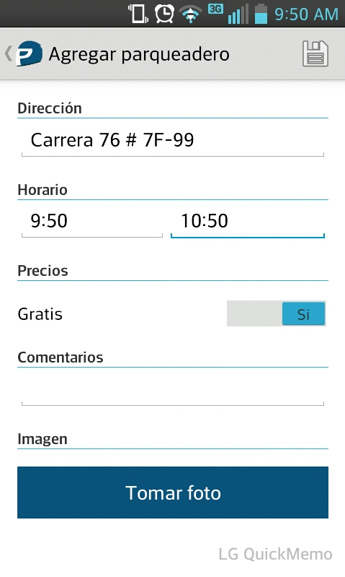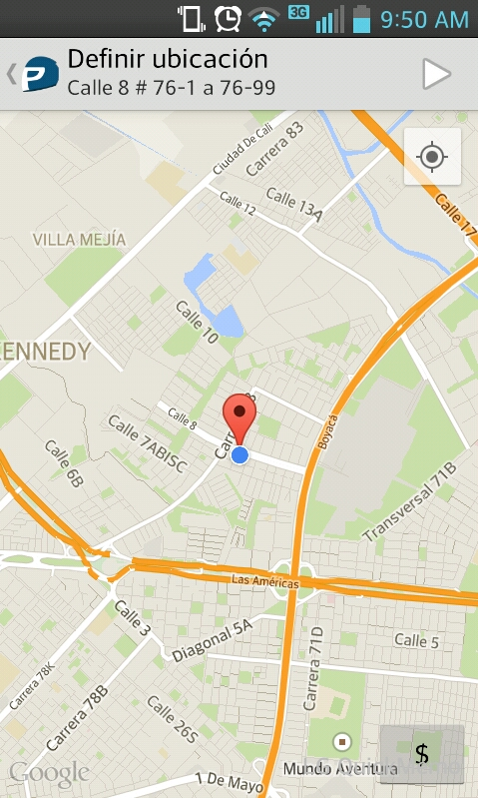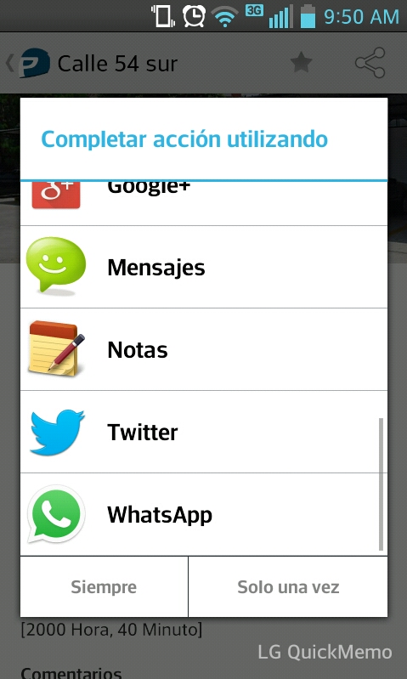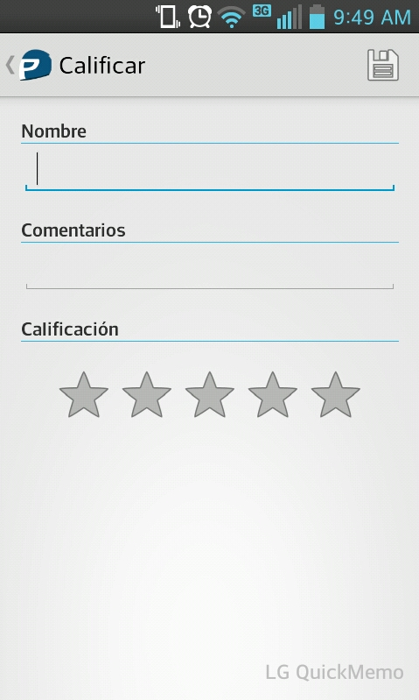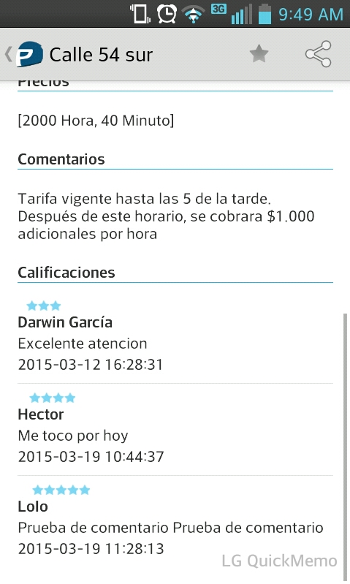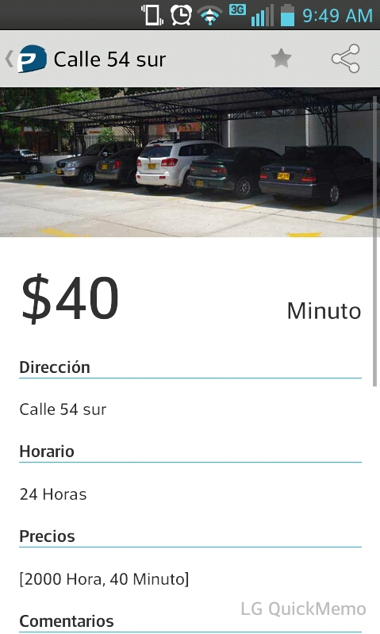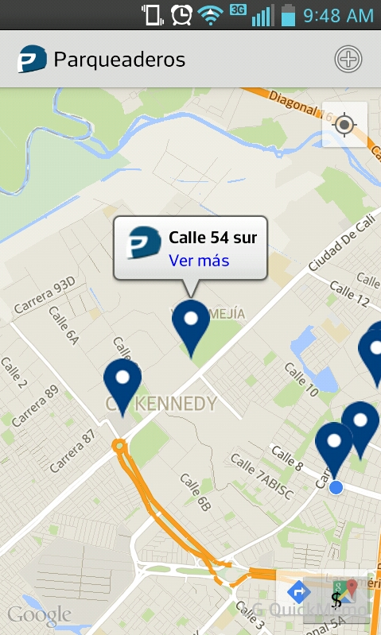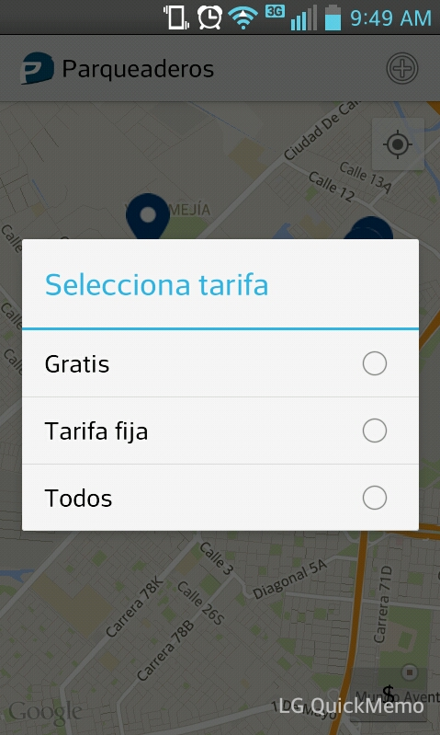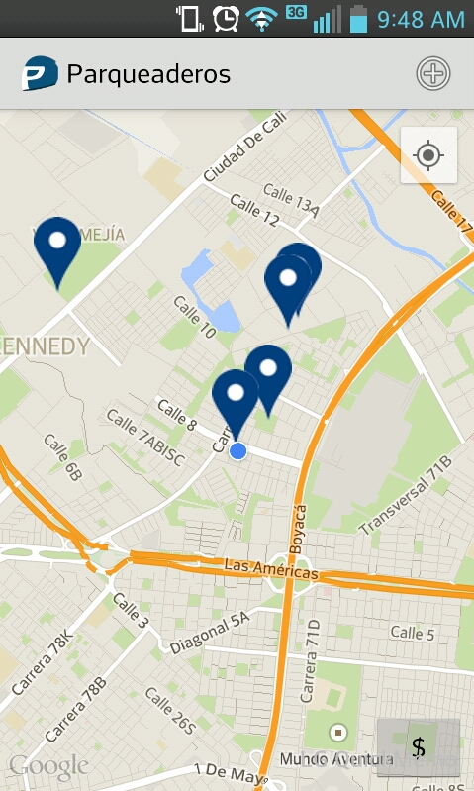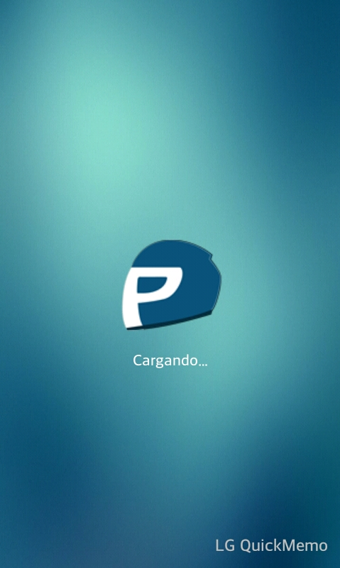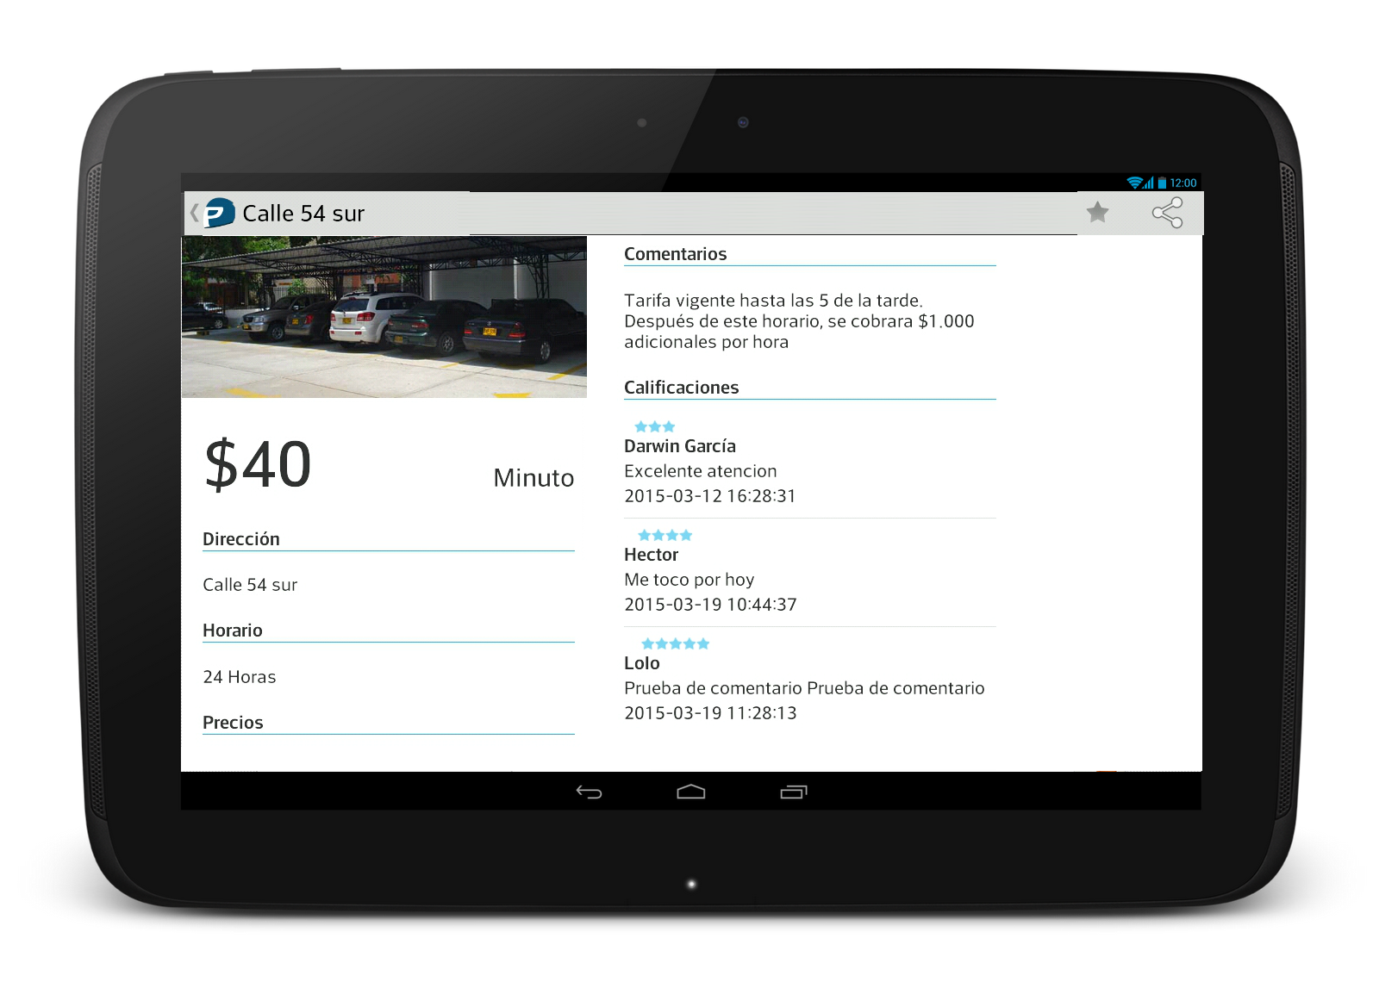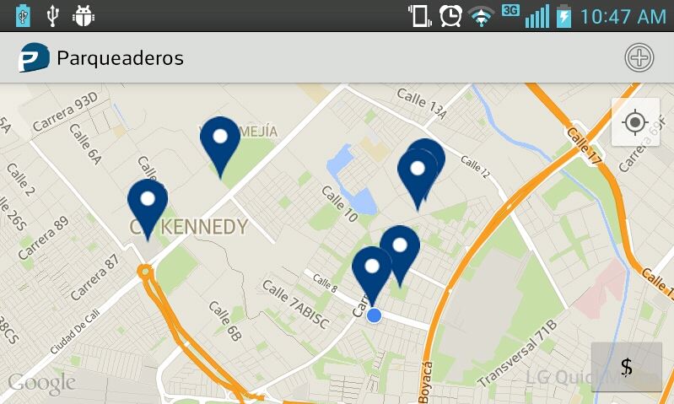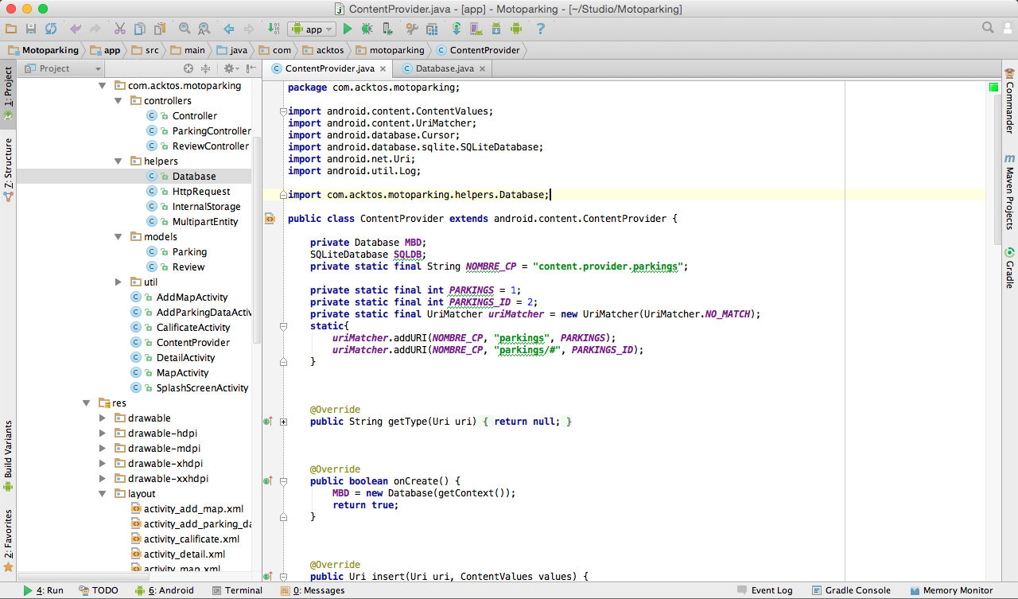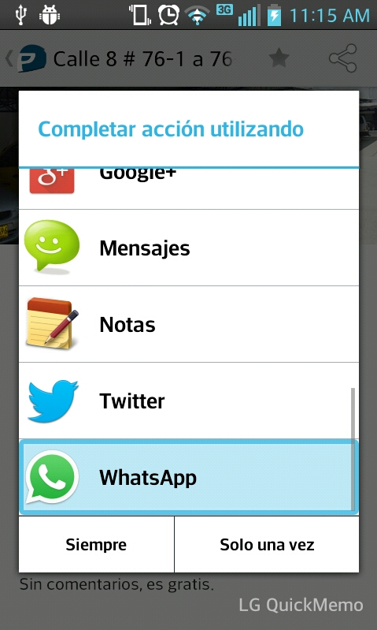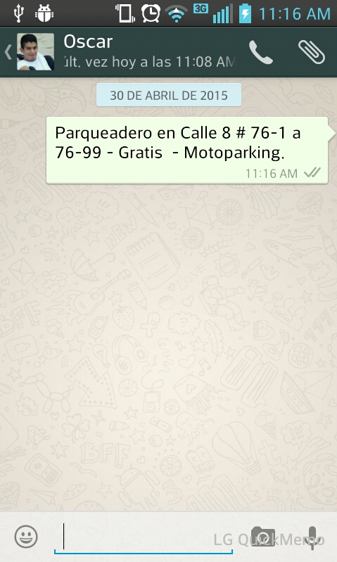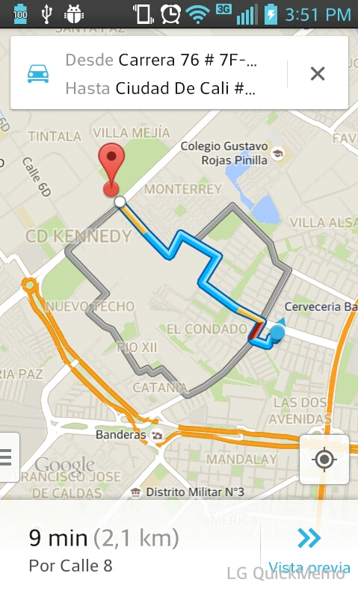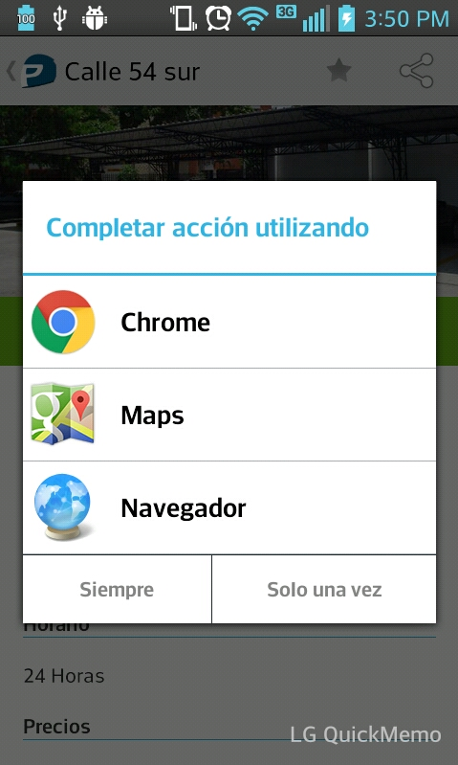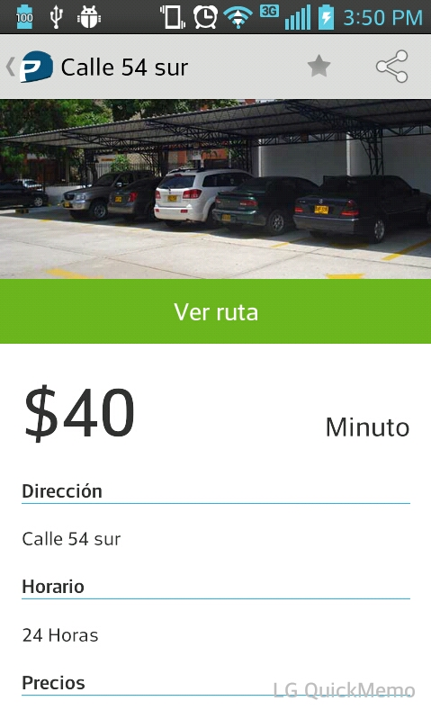

#### Package Name

April 30

2015

Sebastian Felipe Rincon C

Engineer in Telematics

Developer in ACKTOS

Find your nearest motorcycle parking

Motoparking

com.acktos.motoparking

Find your nearest motorcycle parking

Motoparking

Description of the problem

PAGE 3

Screenshots

PAGE 4 – 5

Tablet Design

PAGE 6 - 7

Rotate Screen

PAGE 8

Android Permissions

PAGE 9

Content Provider

PAGE 10

Intents

PAGE 11

The route

PAGE 12

Motoparking users can upload their parking site, details of parking and parking data sharing in social networks, whatsapp, etc.

Currently, in Bogota, many motorcyclists unknown motorcycle parking that are free, or that handle a low rate for motorcycle. Finding a parking providing service for motorcycle often complicated and if we find we do not know what kind of treatment given to the bikes in place.

Motoparking born as a solution for motorcyclists are located in Bogota, displaying information about parking lots that are free for motorbikes. It is designed for higher versions of Android 4.0.

The application displays the closest to the current position of the user parking, we can filter by price (free, fixed). Besides, the detail of the parking we can see a photograph, managed prices, hours of operation and star rating.

### 🕿

### 🚍

PACKAGE NAME: COM.ACKTOS.MOTOPARKING

2015

April 30

### Motorcycle parking’s are free?

### Upload my parking and share

CONTENT

## ADDITIONAL

2

3

## THE PROBLEM

The user can add her own parking begin with the location.

Add the parking details, price, schedule, prices and main image.

Can share parking details in social networks, whatsapp, etc.

The user can post her own calification and comment about this parking.

The user can view comments and calcifications for other users about this parking.

##### Rating

##### Calification

##### Share

##### Add my parking

##### Add details parking

##### Touch marker

The user touch a marker and show the address from parking, and can see more of this parking.

##### Map

View map with near parkings, the user is located by geolocation.

##### Filter

The user can filter by free parkings or parkings with standard rate.

Parking details. Prices, schedule, comments and rating.

##### Detail

Loading Screen Parking Information.

##### SplashScreen

4

5

##### TABLET DESIGN

The tablet design based in fragments, the left side shows the image and the detail from parking. The right side shows the comment list about the parking and the ratings.

6

7

### READ EXTERNAL STORAGE

### 🚍

Allow the read of file .txt of parkings in app.

### WRITE EXTERNAL STORAGE

### 🚍

Write the list of parkings in a file .txt for the app.

### 🚍

### ACCESS COARSE LOCATION

Allow the geolocation of the user by cell towers or Wifi.

### ACCESS FINE LOCATION

Allow the geolocation of the user by GPS, cell towers or Wifi.

### 🚍

The app can access information about the network.

### 🚍

### ACCESS NETWORK STATE

Allow app the connection to Internet for open network sockets, to communicate the app with the web server in python-django.

### 🚍

### INTERNET

## ANDROID PERMISSIONS

9

# Rotate Screens Change

#### The app have a responsive design, which allow the rotate screens in the device and work properly with the app lifecycle.

8

12

##### CONTENT PROVIDER

The content provider manage access to a structured set of data. In the app, the content provider is call ContentProvider and manage the data of parkings that are saved in a database.

11

# Intent (Share)

#### Through this intent, the user can share the parking information to other users, in these images, share the details of parking to another user in whatsapp.

12

#### Through this option, the user can view the route to the parking from its current location.

# Google Maps Route